
FACULTY OF INFORMATICS & DESIGN
2023
Individual Design Contribution (15%)
COVER PAGE

NAME and SURNAME | NORMAN NEL
STUDENT NUMBER | 219359660

Please don’t forget to sign below.

I DECLARE THAT THE ASSIGNMENT SUBMITTED IS MY OWN WORK:



NORMAN NEL 219359660 10/11/2023
Printed NAME and SURNAME  of STUDENT |  | SIGNATURE of  STUDENT |  | DATE

Research on Existing Solutions:
Introduction:
The importance of researching existing solutions helps mitigate risk, allowing the evaluation of reviews and potential challenges. It teaches you industry practices, practical approaches which results in informed decision making.
Existing Solutions Identified:
- Three-tier Data Center Networks
- Tiered network architecture
Case Studies or White Papers Reviewed:
- An article published in February 2022 which speaks about two-tier, spine-leaf and three-tier architectures.
Key Takeaways:
- New problems require new solutions and with legacy 3 tier networks it introduces loops requiring correct stp configuration which is the reason for network outages.
- Modern data centers require two tier spine and leaf architectures enabling high-throughput and low-latency.
Evaluation of Current Network Architecture:
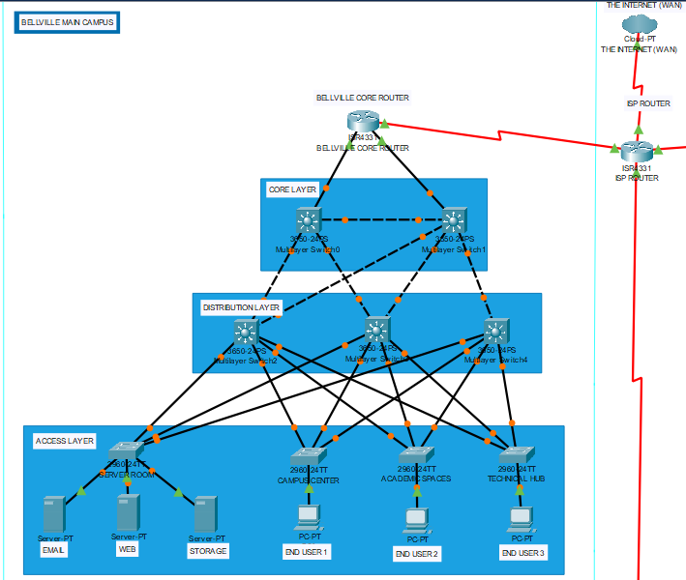
Current Architecture Overview:
- The network architecture is a 3-tier network architecture consisting of 3 layer namely core, distribution and access layer.

Bottlenecks and Inefficiencies:
- Stp loops is causing problems with packets reaching destination devices.
Potential Improvement Areas:
- Changing layer 3 switchport, issuing the “no switchport” command to enable routing.
Hardware & Software Recommendations:
Recommended Hardware:
- PCs representing end users accessing different areas on the campus network
- Layer 2 access switches to forward mac addresses
- Layer 3 core and distribution switches to help route packets from one area to another
- Routers to enable forwarding of ip routing packets
Recommended Software:
- Packet tracer for setup
- Wireshark for network monitoring
Detailed Design Document:
Introduction:
- Core routers
- Layer 2 access switches
- Layer 3 core and distribution switches
Network Architecture Diagram (Using Packet Tracer):
[in zip folder]
Hardware and Software Descriptions:
Core Router:
Functionality: High-capacity routing between networks.
Role: Efficient traffic forwarding within the infrastructure.

Layer 3 (L3) Core Switch:
Functionality: High-speed Layer 3 switching.
Role: Aggregates and routes traffic within the local network.
Layer 3 (L3) Distribution Switch:
Functionality: Inter-VLAN routing and traffic control.
Role: Aggregates traffic from access switches and connects to the core.
Layer 2 (L2) Access Switch:
Functionality: Connects end-user devices to the local network.
Role: Implements VLANs and enforces security policies.
PCs (Personal Computers):
Functionality: End-user devices for network interaction.
Role: Utilizes network services for tasks like email, web browsing, and file storage.
Servers (Email, Web, Storage):
Functionality:
Email Server: Manages email communication.
Web Server: Hosts websites and serves web content.
Storage Server: Manages centralized storage resources.
Role: Enables email communication, hosts websites, and manages storage
Benefits of the Proposed Design:
- Improved scalability
- Enhanced flexibility with L3 Switching
- Optimized Traffic Flow and Redundancy
Potential Challenges:
- Complexity and Management Overhead:
- Issue: Increased complexity with Layer 3 functionality.
- Mitigation: Employ robust network management tools, automation, and thorough training.
- Cost Implications:
- Issue: Additional costs for hardware, licensing, and maintenance.
- Mitigation: Conduct a comprehensive cost-benefit analysis, explore cost-effective alternatives, and consider phased implementation.
- Security Concerns:
- Issue: Expanded attack surface with Layer 3 functionality.
- Mitigation: Implement robust security measures, including firewalls, regular audits, and strict access controls.

